**Assisted Practice: 1.1 Import Bootstrap in Your Application**

This section will guide you to:

* Create an HTML page in your IDE
* Include bootstrap to your web application

This lab has four subsections, namely:

1.1.1 Writing an HTML page in your code editor

1.1.2 Adding bootstrap to your application using CDN

1.1.3 Hosting bootstrap locally

1.1.4 Pushing the code to Github repositories

**Step 1.1.1:** Writing an HTML page in your code editor

* Open Visual Studio Code and create a new file to type the code in
* Right clickon the **File menu** of the code editor -> Select *New File*
* Enter the below code resolving the warning and errors due to compatibility-related issues
* Right clickon the **File menu** of the code editor -> Select *Save as* -> Enter the filename (index.html) -> Click *Save*

**<!DOCTYPE html>**

**<html lang="en">**

**<head>**

**<title>Web Development Blog</title>**

**<meta charset="utf-8">**

**<meta name="viewport" content="width=device-width, initial-scale=1">**

**</head>**

**<body>**

**<h1>Web Development Blog</h1>**

**<p>This blog discusses web development tools and libraries.</p>**

**</body>**

**</html>**

**Step 1.1.2:**  Adding bootstrap to your application using CDN(Content Delivery Network)

* Update the head section of your code to match the code below resolving the warning and errors due to compatibility-related issues.

**<!DOCTYPE html>**

**<html lang="en">**

**<head>**

**<title>Web Development Blog</title>**

**<meta charset="utf-8">**

**<meta name="viewport" content="width=device-width, initial-scale=1">**

**<link rel="stylesheet" href="https://stackpath.bootstrapcdn.com/bootstrap/4.1.3/css/bootstrap.min.css" integrity="sha384-MCw98/SFnGE8fJT3GXwEOngsV7Zt27NXFoaoApmYm81iuXoPkFOJwJ8ERdknLPMO" crossorigin="anonymous">**

**</head>**

**<body>**

**<h1>Web Development Blog</h1>**

**<p>This blog discusses web development tools and libraries.</p>**

**</body>**

**</html>**

**Step 1.1.3:** Alternatively, Hosting bootstrap locally

* Download the bootstrap files from <https://getbootstrap.com/docs/4.2/getting-started/download/>

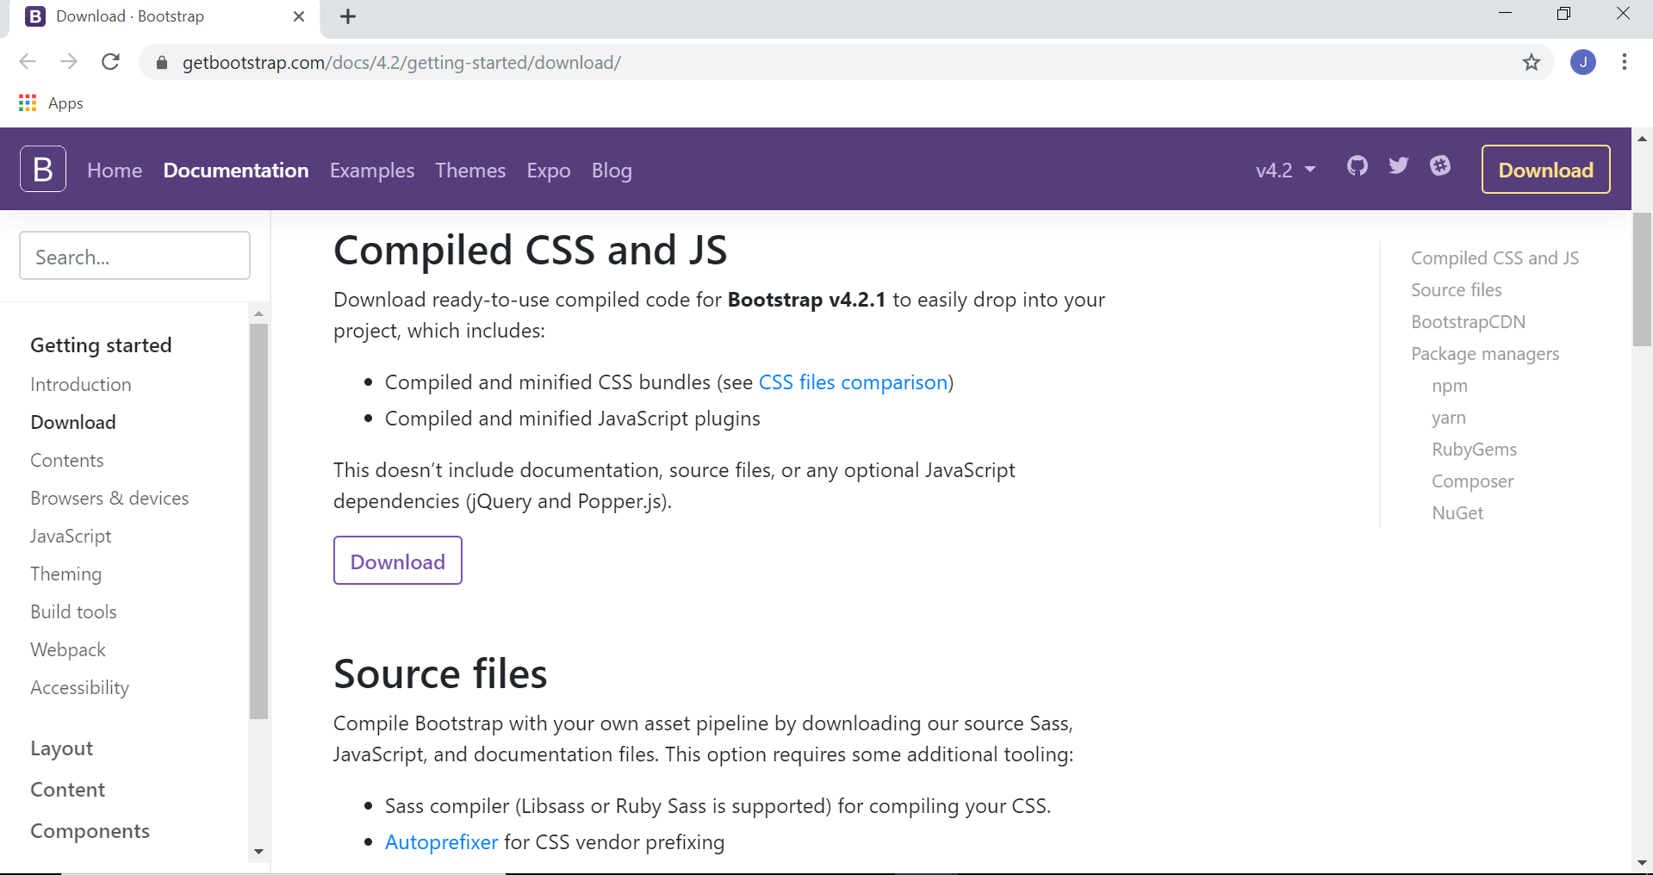

* Unzip the file and copy its contents into the same directory as index.html.
* Open the index.html file.
* Right clickon the **File menu** of the code editor -> Select *Open File -> index.html*
* Add the following line in the head section.

**<link rel="stylesheet" href="bootstrap/css/bootstrap.min.css">**

* Save and load the file in a browser to view the result.

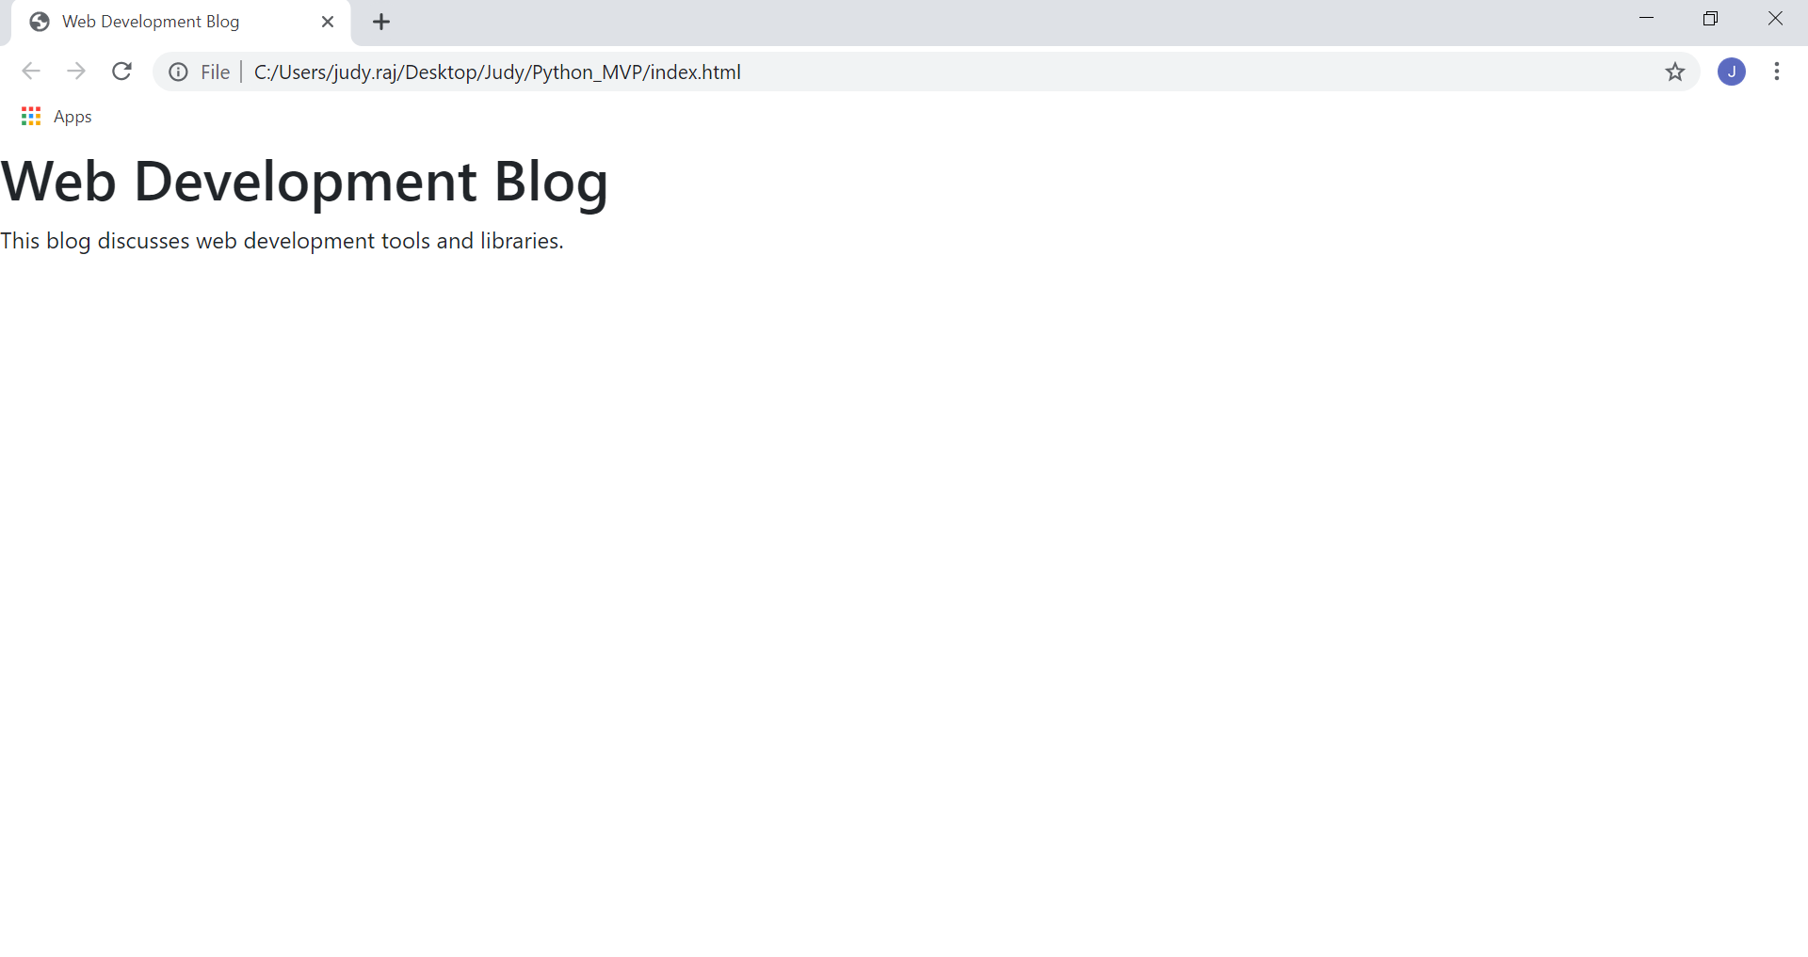

**Step 1.1.4:** Pushing the code to your GitHub repositories

* Open your command prompt and navigate to the folder where you have created your files.

**cd <folder path>**

* Initialize your repository using the following command:

**git init**

* Add all the files to your git repository using the following command:

**git add .**

* Commit the changes using the following command:

**git commit . -m “Changes have been committed.”**

* Push the files to the folder you initially created using the following command:

**git push -u origin master**